# Worksheet 2 Processor performance

**Task 1 Word length**

1. Memory is divided into equal units called **words**. Each word has a separate memory address.

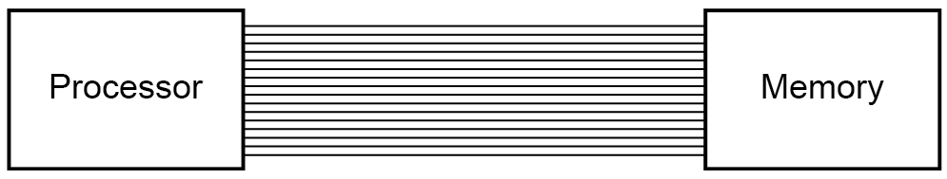

A processor uses a word length of 16 bits and has an address bus of 16 lines.

1. What is the maximum number of addressable words in memory?

2^16 = 65536

1. What is the overall memory capacity in KiB?

8 KiB

1. How does the width of the address bus affect system performance?

The greater the width of the address bus, the more addresses you can have because more unique addresses can be requested.

1. How does the width of the data bus affect system performance?

The larger the width of the data bus, the more data that can be sent across it in one operation, which means the better the system performance because data can be transferred more efficiently and more instructions at a time.

2. (a) Fill in the blanks from the words or phrases given below.

In computing , **word** is a term for the natural unit of data used by a particular processor design. A word is a fixed-sized piece of data handled as a unit by the instruction set or the hardware of the processor. The number of bits in a word (the wordlength) is an important characteristic of any specific processor design or computer architecture.

**bits computer architecture computing instruction set piece of data processor word length**

(b) Complete the table to say whether each of the following statements is true or false.

|  |  |
| --- | --- |
|  | **True or False** |
| One assembly language instructions is generally translated into several machine code instructions | False |
| The word length of the processor and the width of the address bus are factors in the format of a machine code instruction | True |
| Different types of computers have different architectures and therefore different machine code instruction sets | True |
| A processor with a 16-bit address bus cannot address more than 65,536 memory locations | True |

**Task 2 – Testing system performance**

3. Daniel tests the performance of his computer on the website <https://novabench.com/>

He obtains the following results:

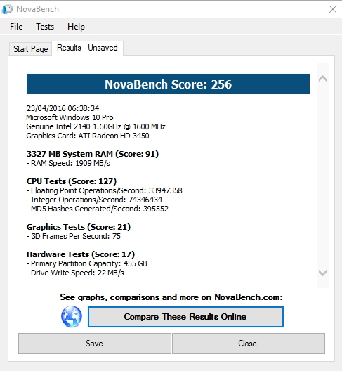

He then compares them against average scores form other users:

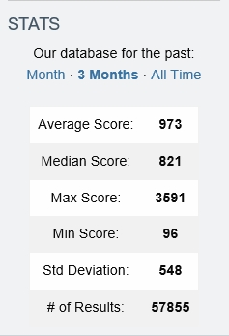

Suggest possible reasons why his computer is performing poorly against the average. Is there anything he could do to improve performance?

Its possible his computer might be really old and since the average is the average of everyone that used it, they likely have more up to date computers which have better processors, more cores, better clock speed, larger caches. He could if he really wanted to, get a better computer with a better processor.

4. Try benchmarking your own computer using the free downloadable software from the website

no.